Scikit Learn Pipelines

Pipelines chains together multiple steps so that the output of each step is used as input to the next step.

Pipelines makes it easy to apply the same preprocessing to train and test!

I am getting this error is the code but needs to complete to complete the task!

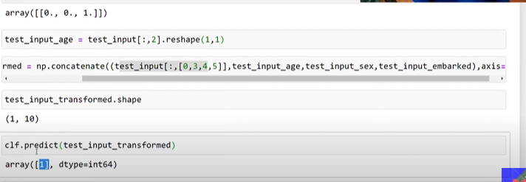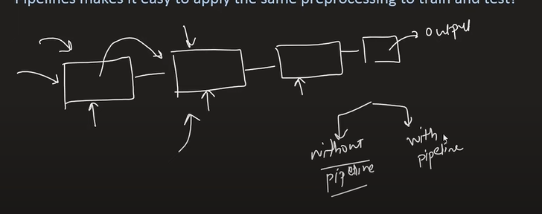

Without the pipeline it is very difficult to run the project on front end because at the time of training if done any changes in the code then the same steps we have to repeat in the production.

Now what will happen in the pipeline :   
